MillSoft Software Migration Document

Description: A migration document which includes the software infrastructure, data structures, dependencies and user interface and user experience documentation.

Infrastructure
Installation: on Premise
Software Environment:
OS: Windows 7
Hardware: Intel i3-4150 CPU Dual core 3.50GHz, 6GB Ram.

Dependencies
Microsoft SQL Server 2005

UI/UX

User Interface:
Login:
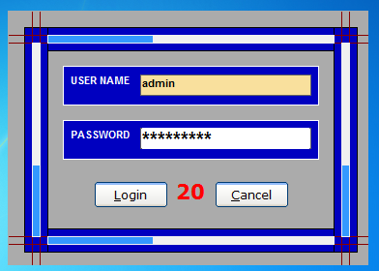
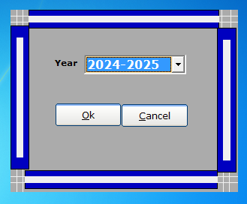

Main User Application:
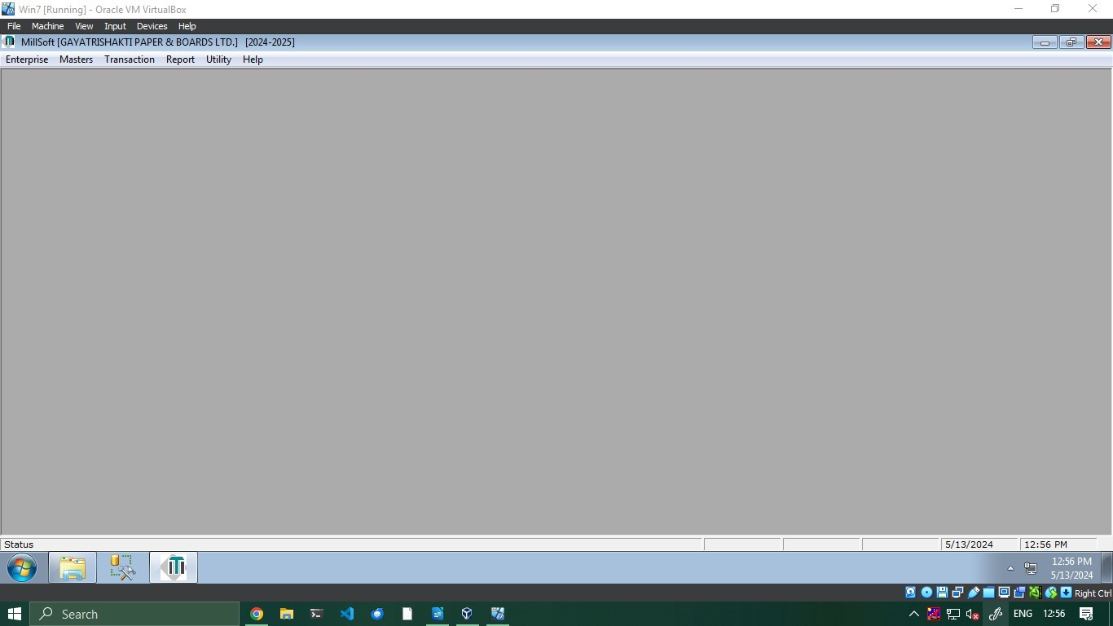

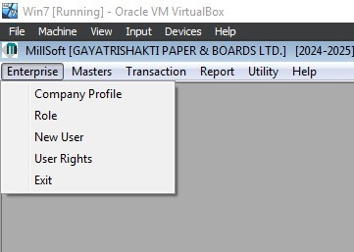
Enterprise:
  - Company Profile:
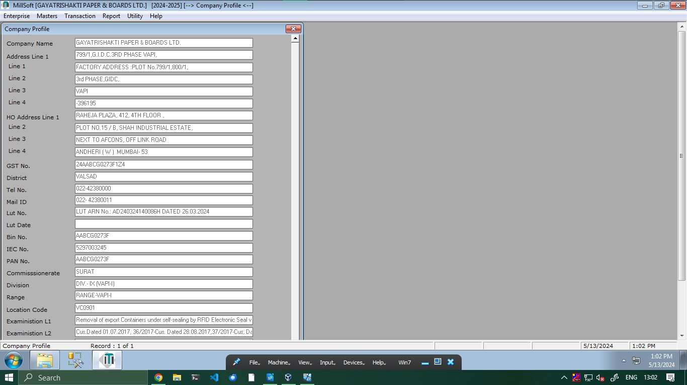
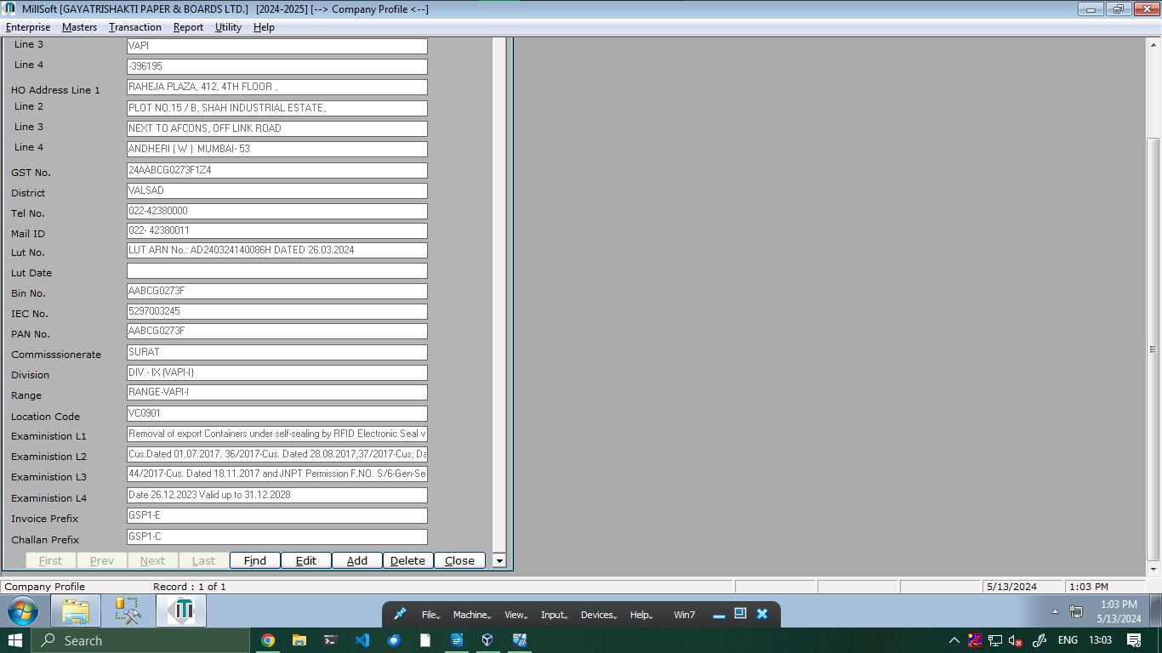
    - Company name
    - Address
    - HO address
    - Gst No.
    - District
    - Tel No.
    - Mail Id
    - Lut no.
    - Lut Date
    - Bin No
    - IEC No
    - Pan No
    - Commisionerate
    - Division
    - Range
    - Location Code
    - Examination L1..L4
    - Invoice Prefix
    - Challan Prefix

  - Role
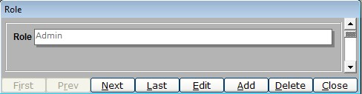
    - Roles can be added or removed

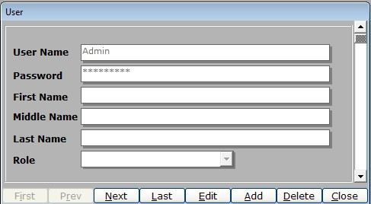
  - New User
    - User Name
    - Password
    - First Name
    - Middle Name
    - Last Name
    - Role

  - User Rights
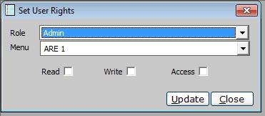
    - Role : Role can be chosen from a list
    - Menu : Menu items can be selected to give permission to the role
    - Read-Write-Access: set permission type

Masters:
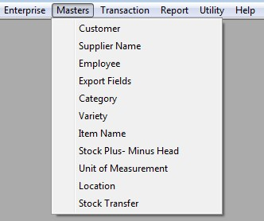
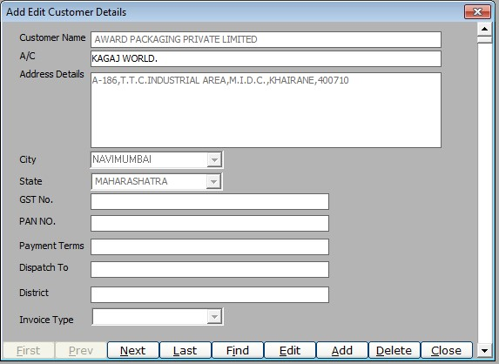
  - Customer
    - Description: Add and Edit customer details by using a Scroll view which scrolls through data rows of the Customer table
    - Labels :
      - Customer Name: Name of the customer
      - A/C : Agent Information ( change the label Agent)
      - Address Details: Address info
      - City: destination City name
      - State : destination State name
      - (Add Pin Code)
      - GST No.: GST no of the Customer
      - Pan No.: Pan no Of The Customer
      - Payment Terms: no of days to make the payment specified by the customer
      - Dispatch To: Not used
      - District:
      - Invoice Type: Not Used (local, Export, On-premise, NFG, Internal)

  - Supplier Name
    - Supplier Name: (Repeated Module )
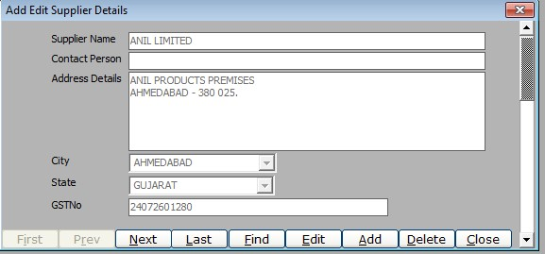
  - Employee (Actually Signatory)
    - Employee Name : Signatory name for Export Invoice
    - Designation : Designation of the signatory
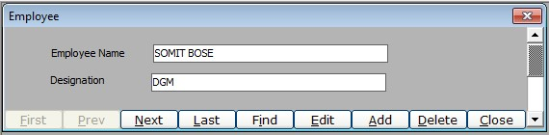
  - Export Fields
    - Description of goods: Name of the product
    - H.S.N Code: Hsn code for the product (gst linked No)
    - Tax Declaration: General Tax document requirement (Subject to change)
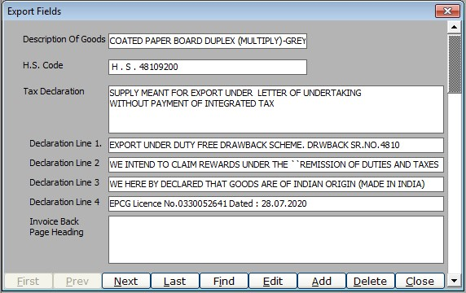
    - Declaration Line 1,2,3,4: General Tax document requirement (Subject to change)
    - Invoice back page heading : Extra Invoice information

  - Category
    - Category : Product category code
    - Unit : unit of measurement for the System
    - HSN code : hsn code for the category Chosen Code
    - Remarks : description of the category code
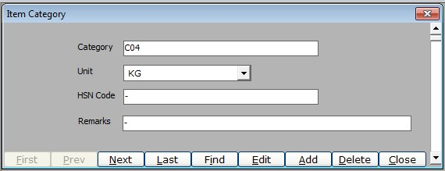
  - Variety
    - Code: (Category Code) Category code for the product
    - Shade Code: Shade of the Product under the category
    - API Grouping :
      - API Code: sub category code
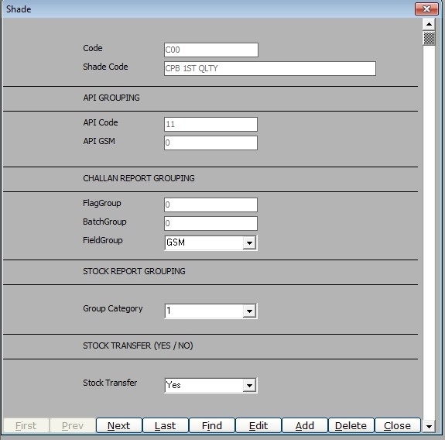
      - API GSM: Summarized GSM Code for Second Quality
    - Challan Report Grouping : variable based Grouping for subtotals
      - FlagGroup:
      - BatchGroup:
      - Field Group : To Group based on the type of stack
  - Item Name
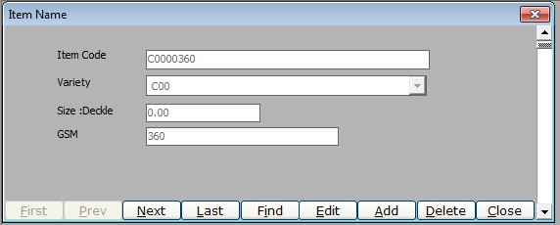
    - Item Code: Product Code For the Specific Item (contains Product type and category)
    - Variety : Sub category of the Item.
    - Size :Deckle: (Change to Size)
    - GSM: (Grams Per Square Meter) of the item

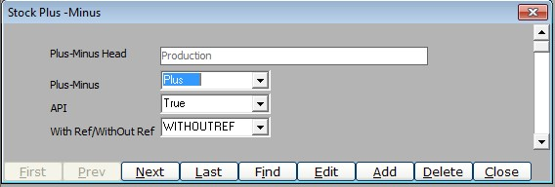
  - Stock PlusMinus Head: (categorizing different damage control and entry correction)
    - plus-minus Head: category of damage control
    - Plus-minus: Should be added to stock or removed from stock/entry
    - API: Validation type for the entry to be in excel
    - With Ref/Without Ref : boolean refer from the damaged or wrong entry.

  - Unit of Measurement: unit of measurement for the entry
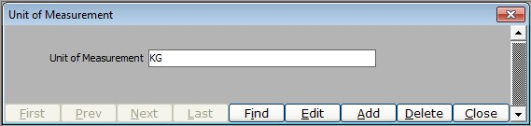
  - Location : Location of the factory sites
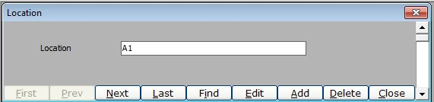
  - Stock Transfer: (For non allocated and ready stock with no party alloted)(item rate master previous name)
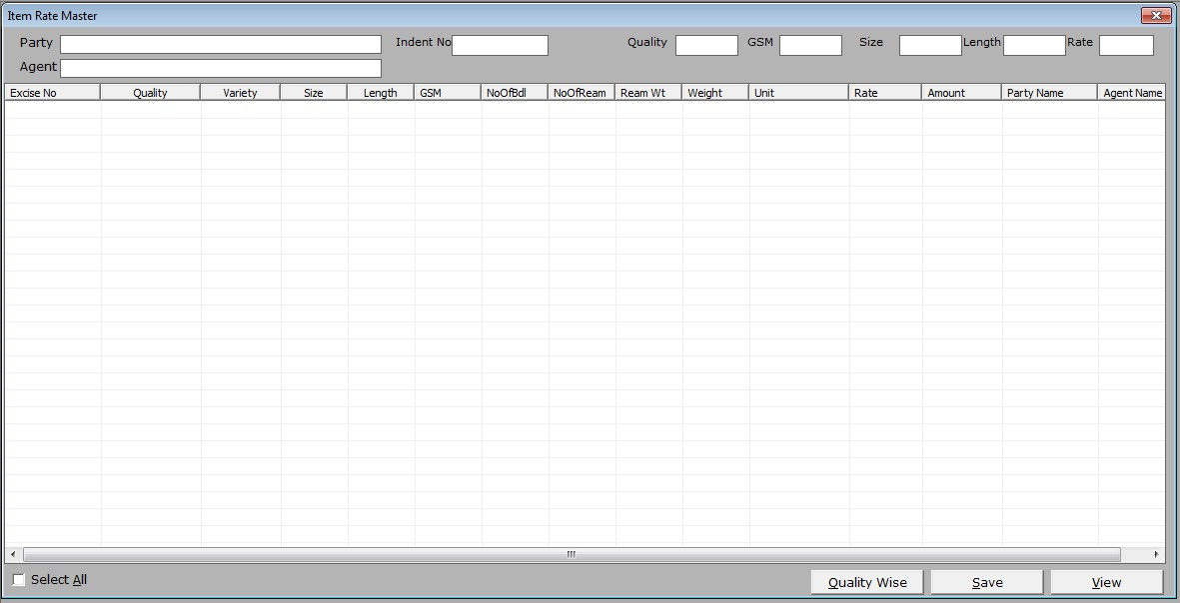
    - party: name of the customer
    - Agent: name of the agent
(Add a Filter section )
    - Indent No : Sales order No
    - quality
    - GSM
    - Size
    - length: For reel the length is 0 / or >0 for deckle
    - Rate: Edit Item rate
    - Table view: can select and edit rate for the item

Transaction:
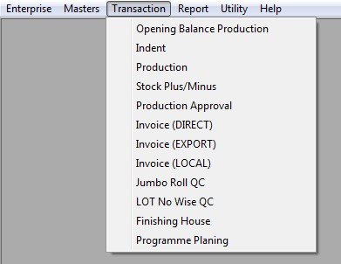
  - Opening balance Production (initial Material Specs )
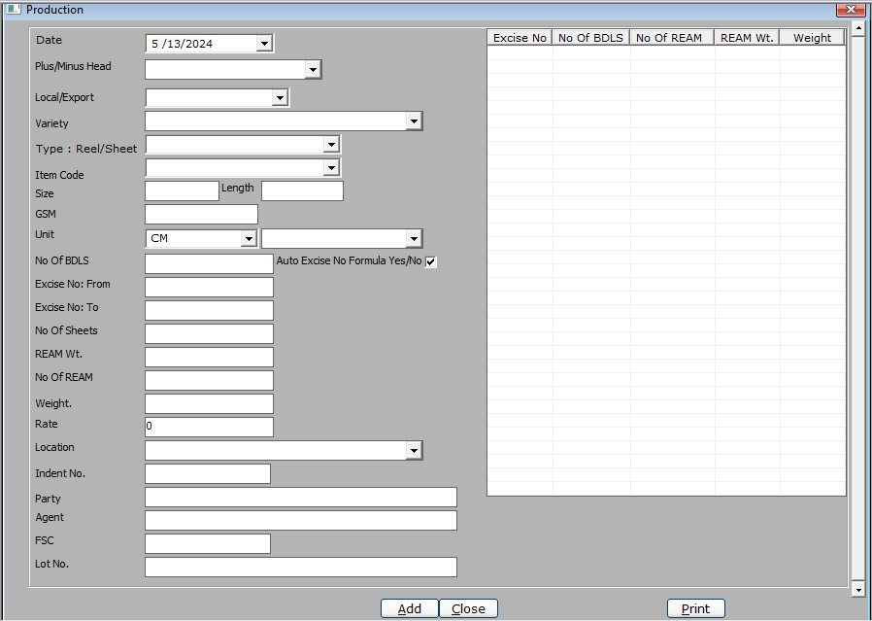
    - Date: date of production of the Material
    - Plus/Minus head: Add or Erased entry for the material
    - Local /Export: For Local Or Export
    - Variety : Sub Category for the product
    - Type : Reel/Sheet : Type of packaging
    - Item Code: item code for the product
    - Size: Width of the Item
    - Length: Length of the product (0 for reel)
    - GSM: Grams Per Square meter unit for the product
    - Unit: unit of measurement for the product
    - No of BDLS: number of bundles packaged
    - Excise No. From: Starting no for the segments for a product Material
    - Excise No. To: Ending no for the segments for a product Material
    - No of sheets: unit of items produced under the same packaging
    - REAM Wt.: Weight of the item packed in a ream
    - No of REAM: No of Reams packaged
    - Weight: Weight of the total Bundles (Reams are packaged in bundles)
    - Rate: Total Product Rate
    - Location: Factory site location
    - Indent No: Sales Order no
    - Party: name of the customer
    - Agent: name of the agent
    - FSC: FSC Certified (boolean)
    - Lot No.:
    - Table View: shows all the individually Segmented Material and the subsequent packages from the segmented Material according to the Excise no of the segmented material.

  - Indent (Not Used)
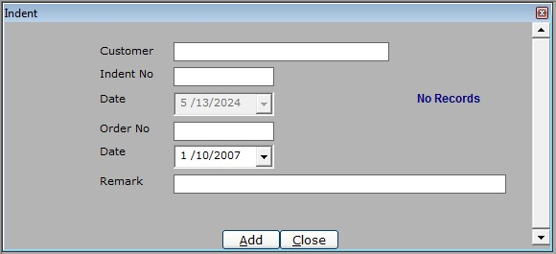
  - Production (records for Production process performed)
    - Date: date of production of the Material
    - Plus/Minus head: Add or Erased entry for the material
    - Local /Export: For Local Or Export
    - Variety : Sub Category for the product
    - Type : Reel/Sheet : Type of packaging
    - Item Code: item code for the product
    - Size: Width of the Item
    - Length: Length of the product (0 for reel)
    - GSM: Grams Per Square meter unit for the product
    - Unit: unit of measurement for the product
    - No of BDLS: number of bundles packaged
    - Excise No. From: Starting no for the segments for a product Material
    - Excise No. To: Ending no for the segments for a product Material
    - No of sheets: unit of items produced under the same packaging
    - REAM Wt.: Weight of the item packed in a ream
    - No of REAM: No of Reams packaged
    - Weight: Weight of the total Bundles (Reams are packaged in bundles)
    - Rate: Total Product Rate
    - Location: Factory site location
    - Indent No: Sales Order no
    - Party: name of the customer
    - Agent: name of the agent
    - FSC: FSC Certified (boolean)
    - Lot No.:
    - Table View: shows all the individually Segmented Material and the subsequent packages from the segmented Material according to the Excise no of the segmented material.
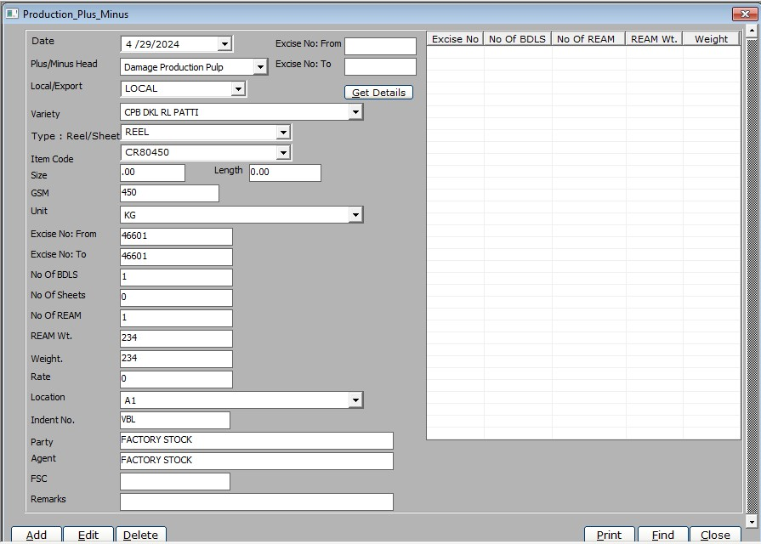
  - Production stock Plus/Minus:
    - Date: date of production of the Item
    - Plus/Minus head: Add or Erased entry for the Item
    - Local /Export: For Local Or Export
    - Variety : Sub Category for the product
    - Type : Reel/Sheet : Type of packaging
    - Item Code: item code for the product
    - Size: Width of the Item
    - Length: Length of the product (0 for reel)
    - GSM: Grams Per Square meter unit for the product
    - Unit: unit of measurement for the product
    - No of BDLS: number of bundles packaged
    - Excise No. From: Starting no for the segments for a product Material
    - Excise No. To: Ending no for the segments for a product Material
    - No of sheets: unit of items produced under the same packaging
    - REAM Wt.: Weight of the item packed in a ream
    - No of REAM: No of Reams packaged
    - Weight: Weight of the total Bundles (Reams are packaged in bundles)
    - Rate: Total Product Rate
    - Location: Factory site location
    - Indent No: Sales Order no
    - Party: name of the customer
    - Agent: name of the agent
    - FSC: FSC Certified (boolean)
    - Lot No.:
(filter)
    - Excise No. From: Starting no for the segments for a product Material
    - Excise No. To: Ending no for the segments for a product Material
    - Table View: shows all the individually Segmented Material and the subsequent packages from the segmented Material according to the Excise no of the segmented material.

  - Production Approval (to approve the new production entries)
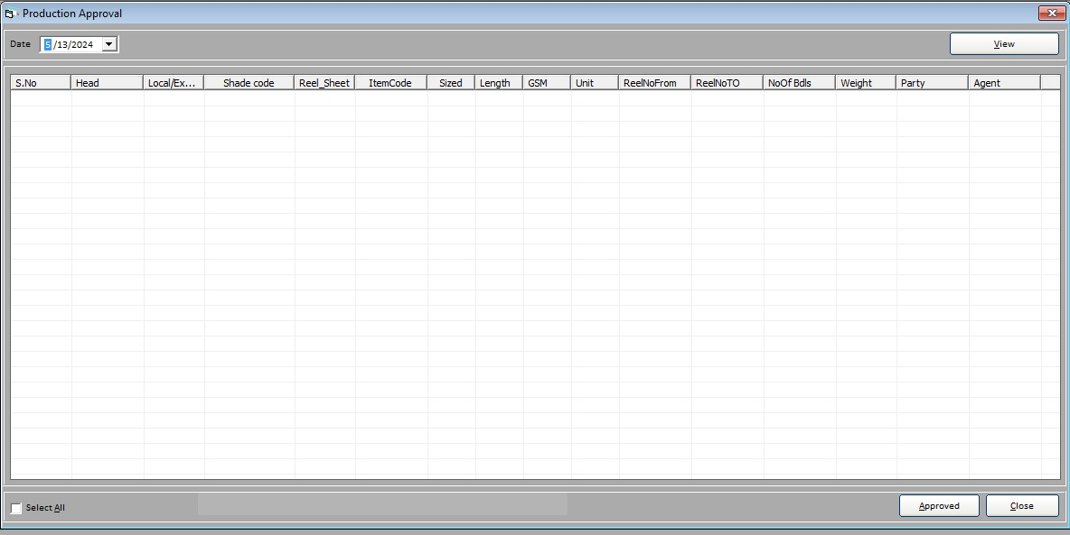
    - Date:
    - Table view:

  - Invoice(DIRECT)
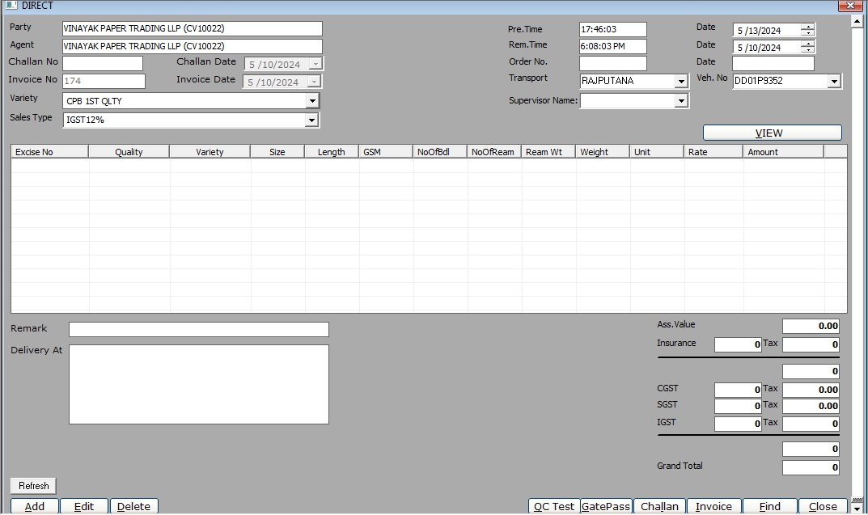
    - party
    - Agent
    - Chalan No
    - Chalan Date
    - Invoice No
    - Invoice Date:
    - Variety
    - Sales Type
    - (Preparation) Pre.Time
    - Pre.Date
    - (Removal)Rem.Time
    - Rem.Date
    - Order No
    - Order Date
    - Transport
    - Vehicle. No
    - Supervisor Name
    - Table View
    - Remark
    - Delivery At
(table view)
    - Ass value
    - Insurance
    - CGST
    - SGST
    - IGST
    - Grand total
(Output)
    - QC Test (template output )
    - Gate Pass (template output )
    - Chalan (template output )
    - Invoice (template output )

  - Invoice(EXPORT)
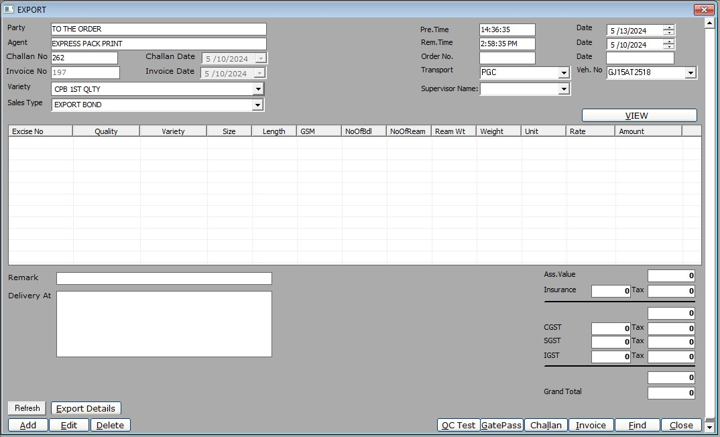
    - party
    - Agent
    - Chalan No
    - Chalan Date
    - Invoice No
    - Invoice Date:
    - Variety
    - Sales Type
    - (Preparation) Pre.Time
    - Pre.Date
    - (Removal)Rem.Time
    - Rem.Date
    - Order No
    - Order Date
    - Transport
    - Vehicle. No
    - Supervisor Name
    - Table View
    - Remark
    - Delivery At
(table view)
    - Ass value
    - Insurance
    - CGST
    - SGST
    - IGST
    - Grand total
(Output)
    - QC Test (template output )
    - Gate Pass (template output )
    - Chalan (template output )
    - Invoice (template output )

  - Invoice(LOCAL)
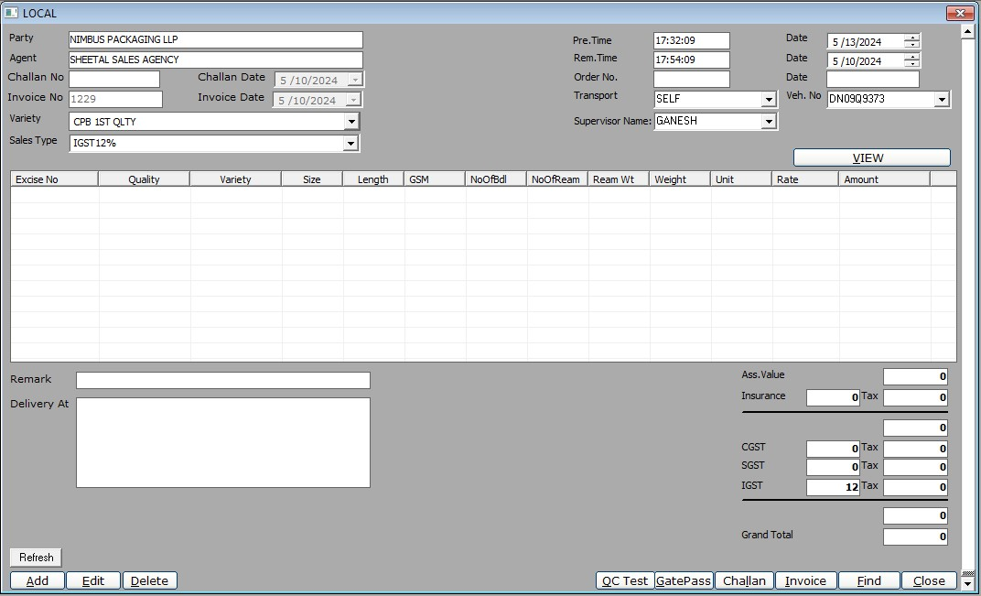
    - party
    - Agent
    - Chalan No
    - Chalan Date
    - Invoice No
    - Invoice Date:
    - Variety
    - Sales Type
    - (Preparation) Pre.Time
    - Pre.Date
    - (Removal)Rem.Time
    - Rem.Date
    - Order No
    - Order Date
    - Transport
    - Vehicle. No
    - Supervisor Name
    - Table View
    - Remark
    - Delivery At
(table view)
    - Ass value
    - Insurance
    - CGST
    - SGST
    - IGST
    - Grand total
(Output)
    - QC Test
    - Gate Pass
    - Chalan
      - View Button
        - option for grouping by all , combination wise , indent wise
        - indent No
        - Gsm
        - Size
        - length
        - order by Reelno , GSM, itemcode , size.
        - Buttons View, Clear
    - QC Test
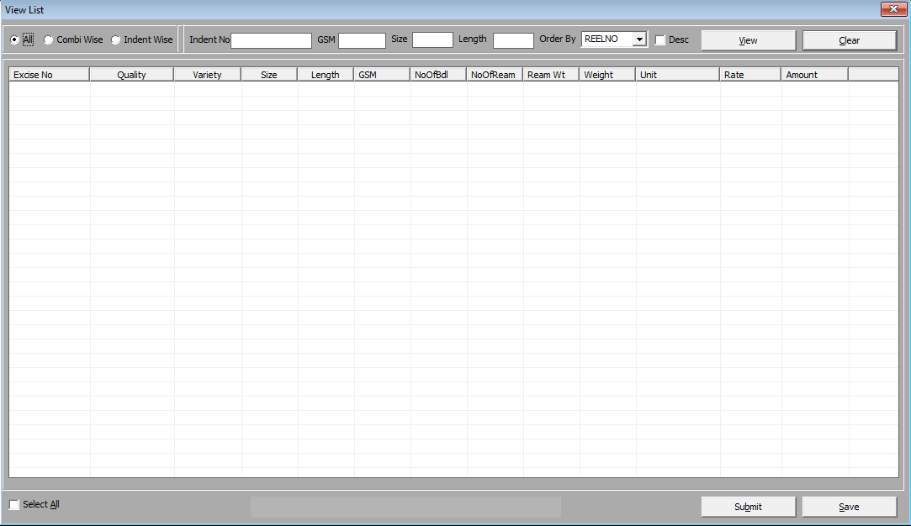
      - view Button

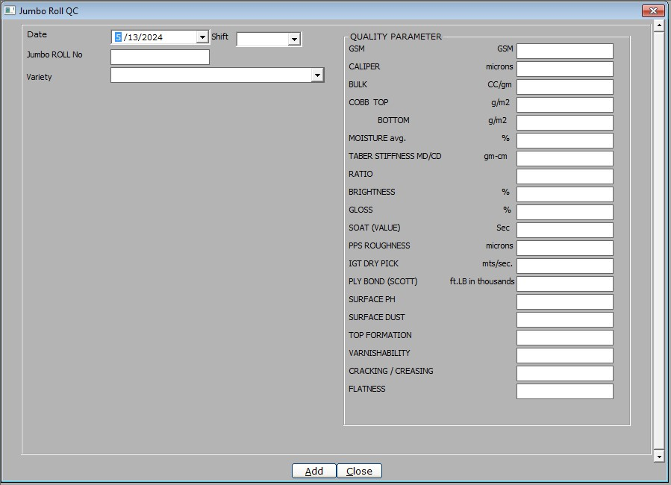
  - Jumbo Roll QC(not used)
    - Date
    - Shift
    - Jumbo Roll no
    - variety
    - formset
      - Gsm (in gsm)
      - Caliper (in microns)
      - Bulk (CC/gm)
      - Cobb top (in g/m2)
      - Cobb bottom (in g/m2)
      - Moisture avg. (in %)
      - Taber stiffness MD/CD (gm-cm)
      - Ratio
      - Brightness(%)
      - Gloss (%)
      - Soat (in Sec)
      - PPS roughness(microns)
      - IGT dry pick (mts/sec)
      - ply bond (Scott) (ft.lb in thousands)
      - Surface PH
      - Surface Dust
      - top formation
      - varnishability
      - cracking /creasing
      - Flatness

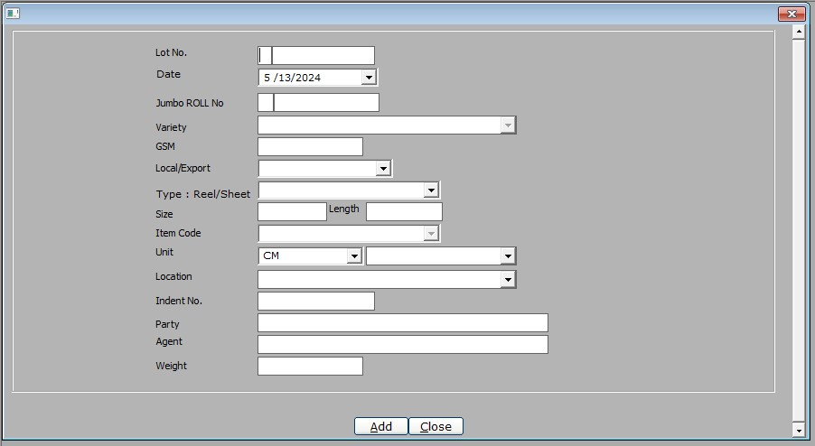
  - LOT No Wise QC(not used)
    - Lot no
    - Date
    - Jumbo Roll no
    - variety
    - gsm
    - Local/Export
    - Type: Reel/Sheet
    - size
    - item Code
    - unit
    - location
    - indent no
    - party
    - Agent
    - weight

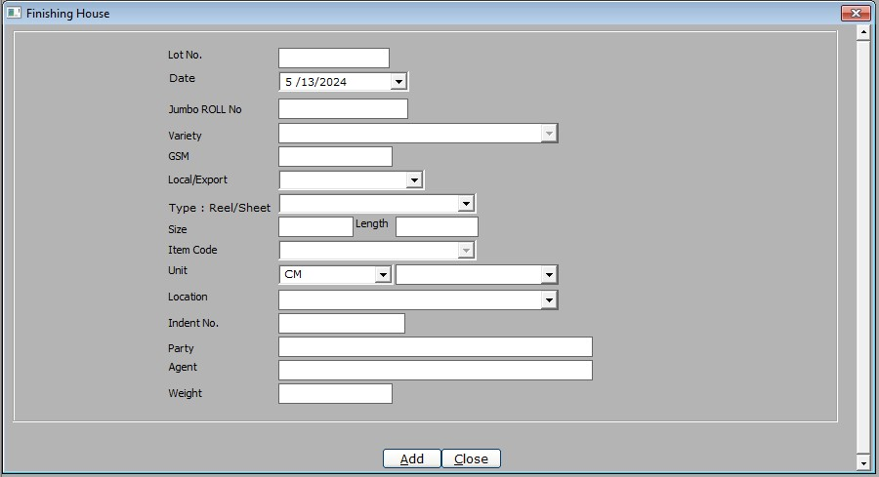
  - Finishing house
    - Lot no
    - Date
    - Jumbo Roll no
    - variety
    - gsm
    - Local/Export
    - Type: Reel/Sheet
    - size
    - item Code
    - unit
    - location
    - indent no
    - party
    - Agent
    - weight

  - Programme Planning
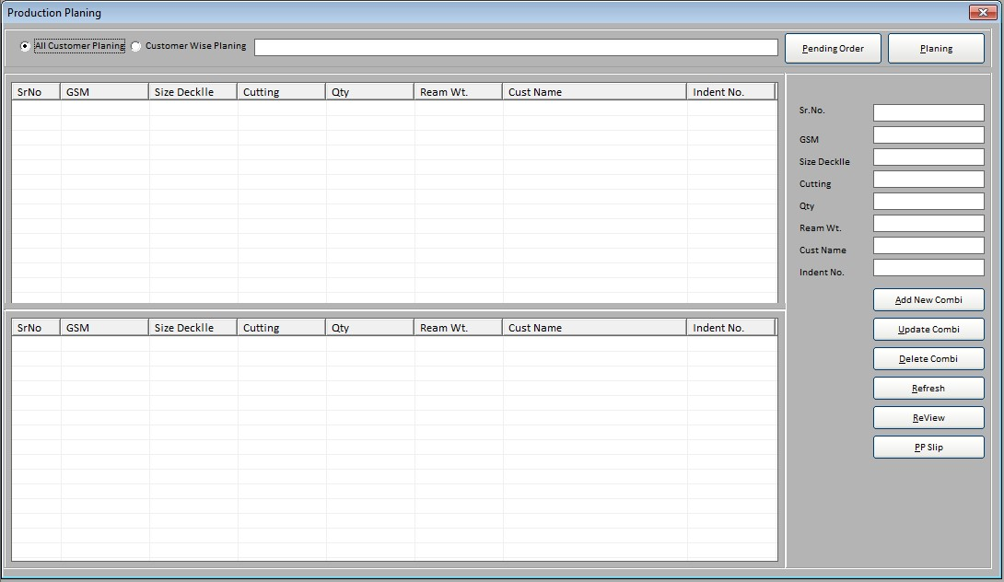
    - planning
      - all customer planning
      - per customer planning
    - sr . No
    - gsm
    - size deckle
    - cutting
    - qty
    - ream wt
    - customer name
    - indent no
    - Ppslip button
      - pdf Template based list

Report
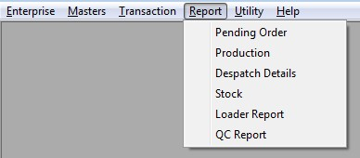
  - Pending Order
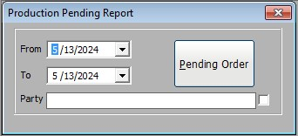
    - excel based report
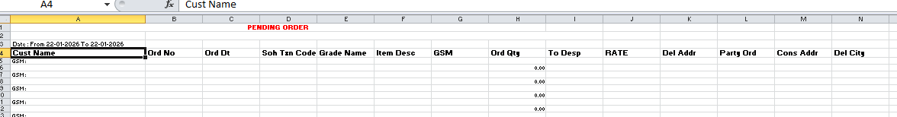

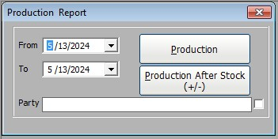
  - Production
    - Production and Production after stock (+/-)
      - excel based reports

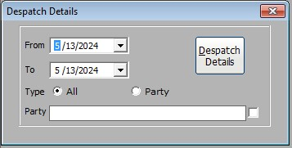
  - Despatch Details
    - Despatch Details
      - excel based report

  - Stock
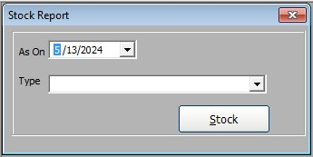
    - stock
      - excel based report

  - Loader Report
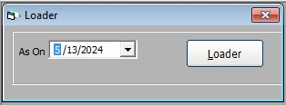
    - loader
      - excel based report

  - QC Report
    - view
      - excel based reports
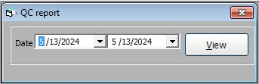

Utility
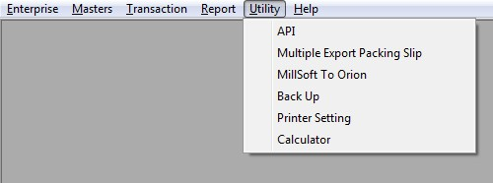
  - API
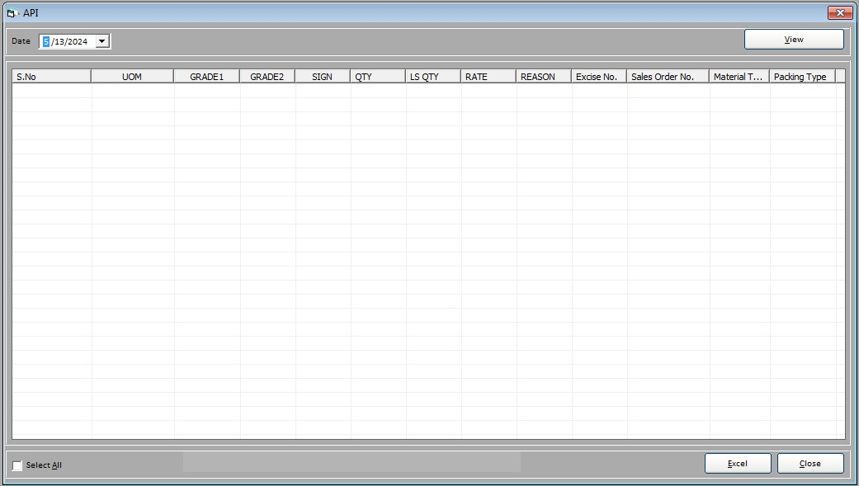
  - Multiple Export packing Slip
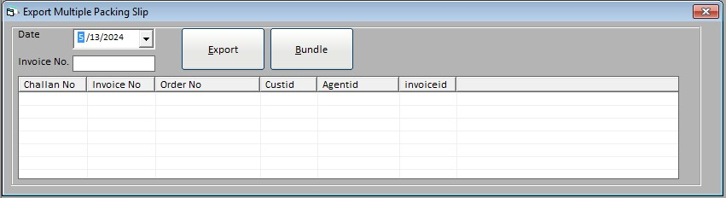
  - MillSoft To Orion
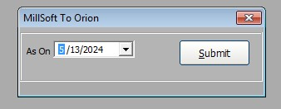
  - Backup

  - Printer Setting
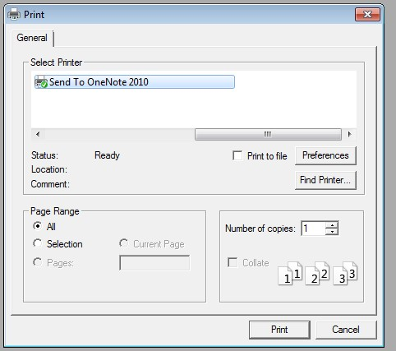
  - Calculator

Help
  - User Documentation
  - Bug Report
  - About

